SEE BACKGROUND MATERIALS CZM PROTOCOLS FOR DETAILED INSTRUCTIONS

Monitoring Checklist.
This checklist is for monitoring only. See the Beetle Rearing checklist for the full set of materials needed for rearing.

This checklist is for monitoring only. (Not rearing beetles. See Beetle Rearing checklist for a full material list including rearing and monitoring.

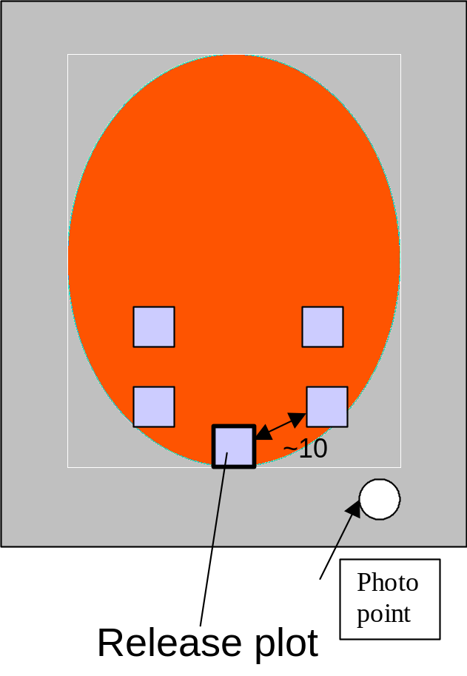

Materials List:

Personal Gear (boots, hip or chest waders, gloves, protective eyewear)

Materials to mark Beetle release site:
Post to mark plot (PVC, metal or colored surveyor flags)
Setting up Monitoring Materials:

Set up materials:
10 metal or PVC pipes to mark quadrat corners.
2 PVC pipes or flagging to mark photo points.
Hammer Permanent Marker
Map of site GPS unit (optional)
Pencil Form 1
Clipboard 50 m tape
1 meter quadrat frame
Camera Flagging

Fall and Spring Class Monitoring Materials:
Permanent marker to refresh quadrat numbers.
Quadrat Frames (purchase or make from PVC pipe)-one for each monitoring team
Pencils (At least 1 per team)
Pencil sharpener
Clipboards (At least 1 per team)
Data Forms (In spring, use Forms 2 & 4. For fall, use 3 & 4)
Field Guides
GPS Unit (optional)
Additional Spring Monitoring only:
1 or 5 stopwatches
Purple loosestrife Beetle Identification Cards

Additional Fall monitoring only:
5 meter sticks or measuring tapes (or one for each team).
Suggested Classroom Prep For Spring:
Materials:
7 loosestrife samples
Hole punch
Quadrat frame
2 of each plant species found in your wetland.
Freshwater Wetlands a Guide to Common Indicator Plants of the Northeast by Dennis W. Magee

If beetles have been released:
- Take a photograph of the site to show where beetles were released and where you released the beetles when the purple loosestrife is in full bloom. Choose a photo point which you can easily return to at the same time and place to take annual photos for monitoring purposes over the years.

Setting up Monitoring Materials:
Set up materials:
10 metal or PVC pipes to mark quadrat corners.
2 PVC pipes or flagging to mark photo points.
Hammer Permanent Marker
Map of site GPS unit (optional)
Pencil Form 1
Clipboard 50 m tape
1 meter quadrat frame
Camera Flagging

Set up monitoring:

- Establish a minimum of 5 permanent quadrats.
- Start at least 5 meters from an edge (roads, streams, upland etc.) Avoid trampling vegetation in and near the quadrat.
- Place quadrats at random into the purple loosestrife infestation. The easiest way to do this is to place the quadrats at predetermined intervals such as every 5, 10, or 20 meters.
- Make sure all quadrats contain at least 30% purple loosestrife, and shift the location if needed.
- Record the position and numbers of the quadrats on the vegetation map on Form 1.
- Use GPS to take coordinates for easy relocation in dense vegetation (if possible, otherwise record sites on map).
- To establish permanent quadrats, locate the position of each quadrat, then place ½ the u-shaped frame into the vegetation as close to the ground as possible. Then attach the second ½ of the quadrat frame. This helps ensure the plot is laid well with the appropriate stems inside the frame. Avoid trampling plants!
- Drive the 1-2 m long plastic or galvanized steel pipes into the ground at least 2 corners to allow for exact placement in future years.
- Allow pipe to stick up for visibility, but low enough to minimize vandalism. Use flagging tape to assist relocation, and notice landmarks to assist with relocation. Make notes to yourself to help remember these landmarks.
- Write the quadrat number on each pipe with a permanent marker.

Form 1 Instructions:
- Road Map: Photocopy a road map and paste it into the space provided.
- Site and Vegetation Map: Provide an aerial photo with access roads with the approximation of purple loosestrife infestation outlined, other vegetation types, trails, creek, etc. Paste this into the space provided. If beetles have been released, indicate with numbers points of single or multiple control agent releases.
- Indicate on the map the location of photo points, and direction picture was taken.

Fall and Spring Class Monitoring Materials:
Permanent marker to refresh quadrat numbers.
Quadrat Frames (purchase or make from PVC pipe)-one for each monitoring team
Pencils (At least 1 per team)
Pencil sharpener
Clipboards (At least 1 per team)
Data Forms (In spring, use Forms 2 & 4. For fall, use 3 & 4)
Field Guides
GPS Unit (optional)
Additional Spring Monitoring only:
1 or 5 stopwatches
Purple loosestrife Beetle Identification Cards

Additional Fall monitoring only:
5 meter sticks or 5 measuring tapes (or one for each team).
Suggested Classroom Prep For Spring:
Materials:
7 loosestrife samples
hole punch
quadrat frame
2 of each plant species found in your wetland.

Freshwater Wetlands a Guide to Common Indicator Plants of the Northeast by Dennis W. Macgee

A. Practice estimating percent plant damage in advance:
Bring in 7 loosestrife plant samples and use a hole punch to create what you think looks like the different percent damage categories. Have students order the plant samples from least to most damage. Have them estimate percent damage.

B. Model what is in and out of the frame in advance. Demonstrate counting only stems that start inside the frame at ground level, not those outside or under the frame.
Review what a stem is and what a branch is.

C. Bring in 2 of each plant found in the wetland and lead students through the plant ID activity.

Spring Monitoring
Do this late spring/early summer, 2-3 weeks after Galerucella adults appear after overwintering at your site.

- Monitor at your release site when loosestrife stems are 12-18 inches (20-30 cm) tall. (May). Look for evidence of adult feeding.
- Prepare monitoring forms by recording site name, date, and names of observers, weather patterns, and time of day of observation. (Beetle behavior varies by weather pattern. This can impact data.)
- Assessing insect abundance. Explain the approach: You will count in fixed time intervals: 1 minute each for eggs, larva, and adults. Have observers positioned on multiple sides of plot. Divide search time by number of observers.
- Carefully approach the quadrat and watch for adults when you slide the quadrat frame into position. Count and record one minute.
- Then do larva (do not open shoot tips, this may harm the larvae.)
- Then do eggs.
- Count or estimate the number of each insect species present. If you are able to count adults, eggs and larvae, please do.
- Scan the purple loosestrife for any damage to leaves or shoots. Look for shotgun feeding pattern of the Galerucella beetles.
- Estimate the percent leaf area of purple loosestrife removed by insect feeding integrated over the entire quadrat, using Chart B. This will initially be low or non-existent. (You can practice this in the classroom)
- Estimate percent cover of purple loosestrife in the plot.
- Count the number of purple loosestrife stems. Beginning at one corner of the quadrate and working systematically across. It must be >20 cm and originate within the quadrat to be counted. (Not under or outside the frame). Count only stems, not branches. A stem originates from the ground or within 5 cm of the ground.
- Count cattail stems using the same method.
- Record other insects found in the plot
- Optional: Use Form 4 to record associated vegetation.
- Take a photo of each plot and mark the photo id on the data sheet.

Fall Monitoring:

Suggested Prep:
Percent cover activity.
Dates: Late August-Early October.
- Fill in data sheets with site name, date, names of observers, weather, temperature, and time of day of observations.
- Locate permanent photo points and take photographs.
- Find quadrat location. Slide frame into place.
- Estimate and record purple loosestrife percent cover.
- Estimate and record percent cover cattail.
- Count and record total number of stems of purple loosestrife.
- Count and record stems of cattail.
- Count and record total number of inflorescences of purple loosestrife (and then do cattail.) Count only those that originate in your quadrat.
- Select the five tallest loosestrife stems. For each stem:
  - Measure stem height
  - Count number of inflorescences on all branches of that stem
  - Measure length of longest inflorescence
  - Count number of flowers in the center 5 cm of the inflorescence
- Select the five tallest cattail stems. For each stem, measure height and indicate if fertile (with flower) or sterile.
- Optional: Record presence (and percent cover) of all plant species rooted in the quadrat (on form 4).
- Take a photo of each plot and mark the photo id on the data sheet.

Be sure that as a class, you complete all 5 quadrats. You may want to have different classes complete different portions of this (using the same data sheet.)

Inflorescences: The portion of the stem above and including the lowest flower bud. Even if only one flower bud is present, it is counted as an inflorescence. Do not count small bundles of reddish leaves.

Stem: Originates from the ground or within 5 cm of the ground.
Branch: originates at least 5 cm above the ground.

